433.92MHZ RF home automation smart socket

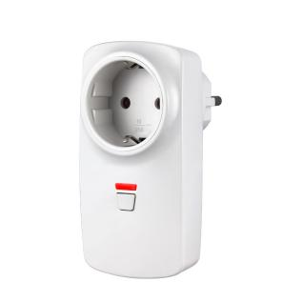

System Introduction
This product adopts international advanced digital RF technology.stable performance, strong memory storage capability, user-friendly.it is only compatible with signal from our alarm system panel ,no direction requirement. It won’t only bring you smart & easy living convenience ,but also protect home electronic from being waste of power, friendly to the resources.

Usage
The socket is a kind of smart alarm accessory, which will be controlled by the command signal from the alarm panel. It is widely used to control the power ON or OFF of home appliance, for example, TV,Fan, light, air conditioner, heater etc.

Learning Way
- Connect the socket to the plug at home, and LED on the socket should be OFF
- Hold the learning button for 2 seconds , release it until you see the LED light on
- Trigger the signal on the alarm panel. Att: please refer to the user manual of each panel about the transmitting way
- The LED light will be flashing after the socket receive the signal successfully

Technical Parameter
- Power supply:AC100-240V
- Plug type: UK, US, EU, AU optional
- Maximum Power:2200W
- Receiving sensitivity:-100dB
- Frequency:433.92MHz
- Receiving distance:10-30M (open area)
- Material:ABS (fire resistance)
- Operation temperature:-20~ 70
- Maximum current:10A
- Humidity:less than 80 %

